|  |
| --- |
| Close-up image showing the leaf-sides of two oversized books side-by-side on a bookshelf, with additional books in soft focus background |
| Computer Architecture |
| |  |  |  | | --- | --- | --- | |  |  |  | |



**Name:** Yousef Ehab Mohamed Abdel Aziz

**B.N. :** 1104

**Group:** 8

**Date:** 06/06/2021

**Topic:** Computer Architecture

**Application brief:**

**1) What does computer architecture mean?**

Computer architecture is a specification detailing how a set of software and hardware technology standards interact to form a computer system or platform.

Computer architecture refers to how a computer system is designed and what technologies it is compatible with.

Computer architecture is likened to the art of determining the needs of the user/system/technology, and creating a logical design and standards based on those requirements.

**2) What is the importance of computer architecture in a computer system?**

Computer architecture” refers to the underlying structure of the computer system. In the case of a computer system, this includes instruction set, numeric sizes and representations, and how the system connects to external devices (interrupts or polling).

While in the theoretical sense, most architectures are functionally equivalent, it does not mean that some architectural choices make some applications and algorithms easier or more efficient to implement. An architecture without support for floating point can be extended in software to perform the needed functions, but it will generally be slower than a hardware implementation. In the interfacing device area, interrupts make it more efficient to overlap device operation with computing. Such operations can be done without interrupts, but it is far more complex.

In summary, computer architecture defines the underlying structure of the computing system. It governs how the various elements interact.

**Screenshots:**

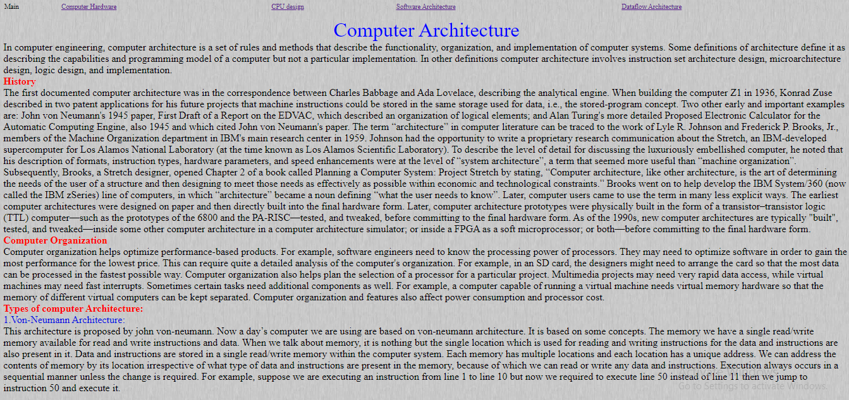

Img.1 computer architecture

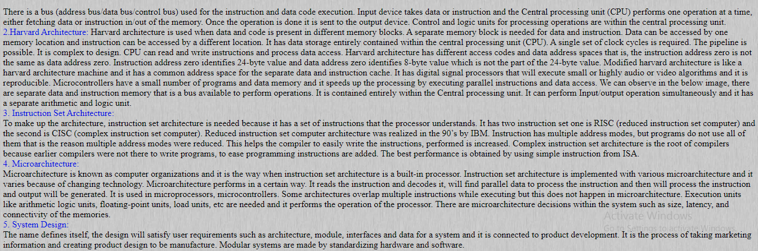

Img.2 computer architecture

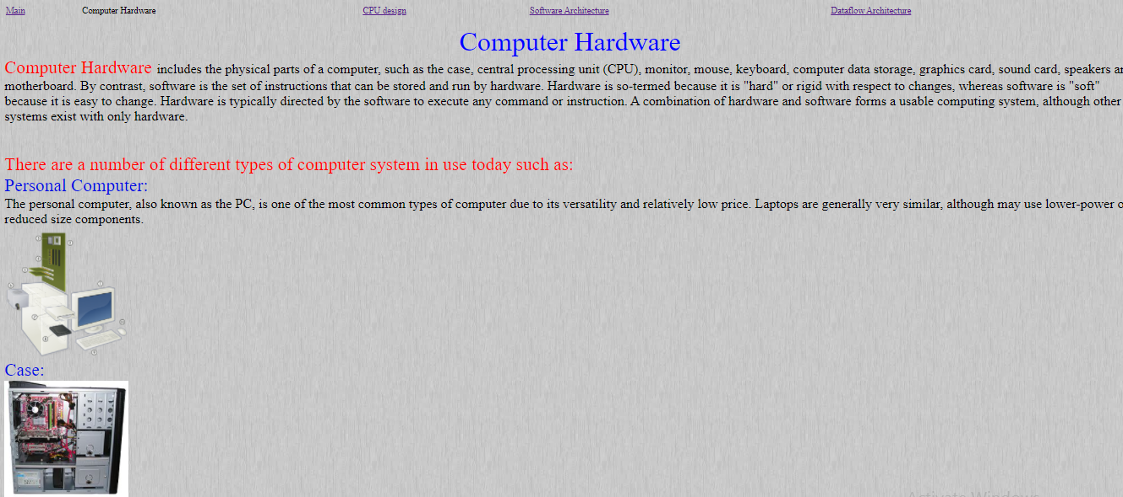

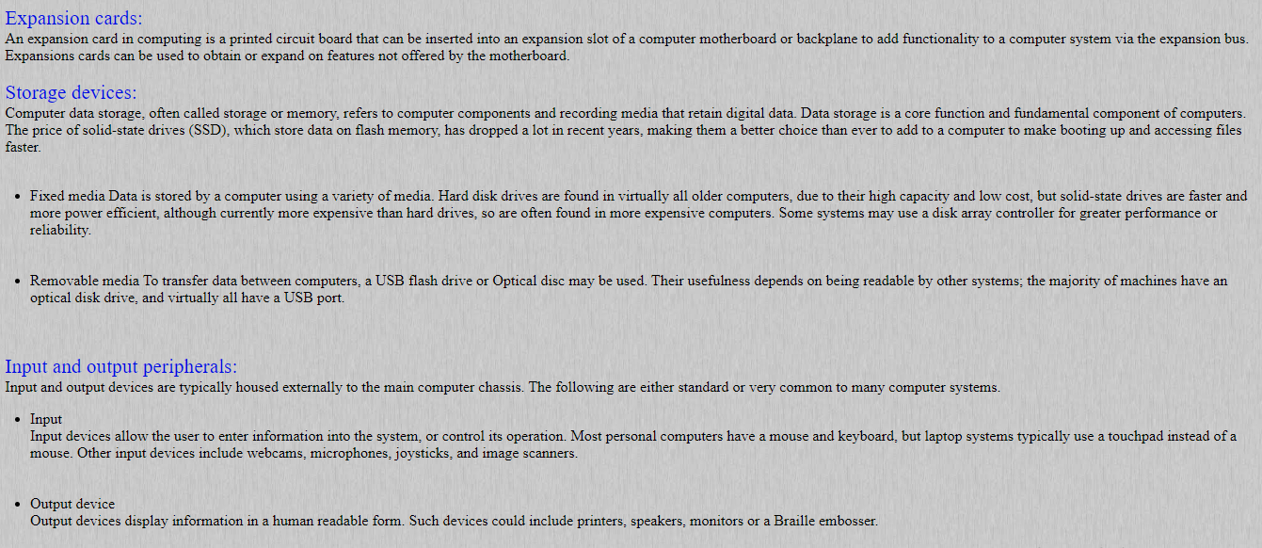 img.3 Computer Hardware

img.4 Computer Hardware

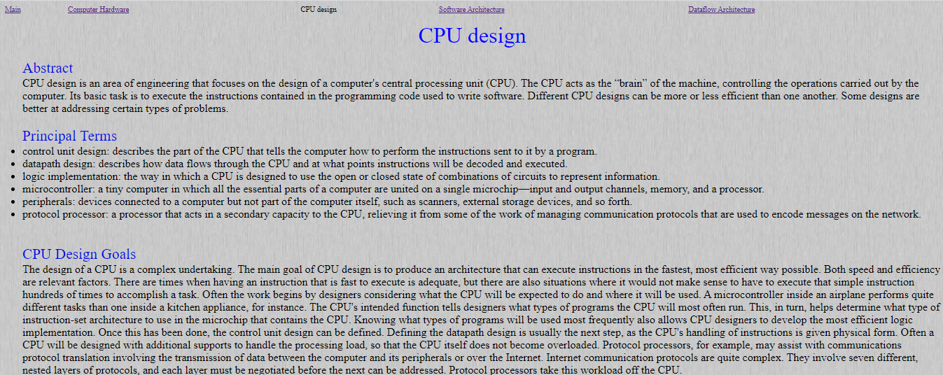

img.5 CPU design

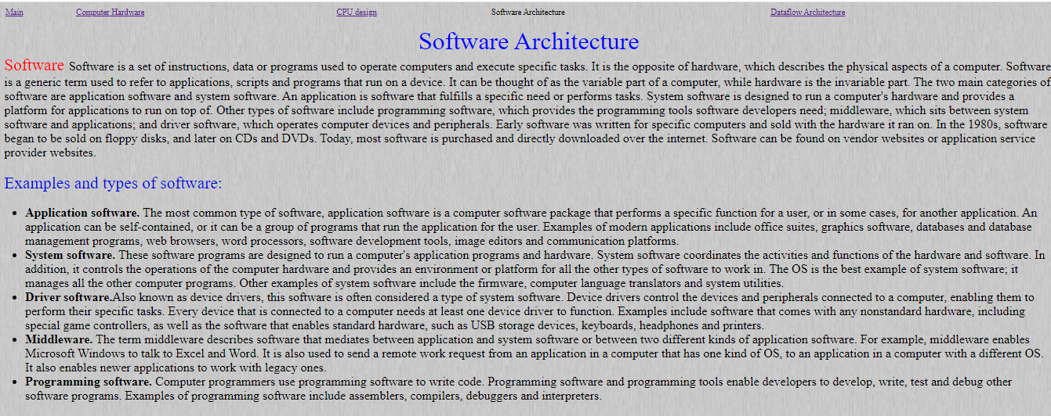

img.6 Software Architecture

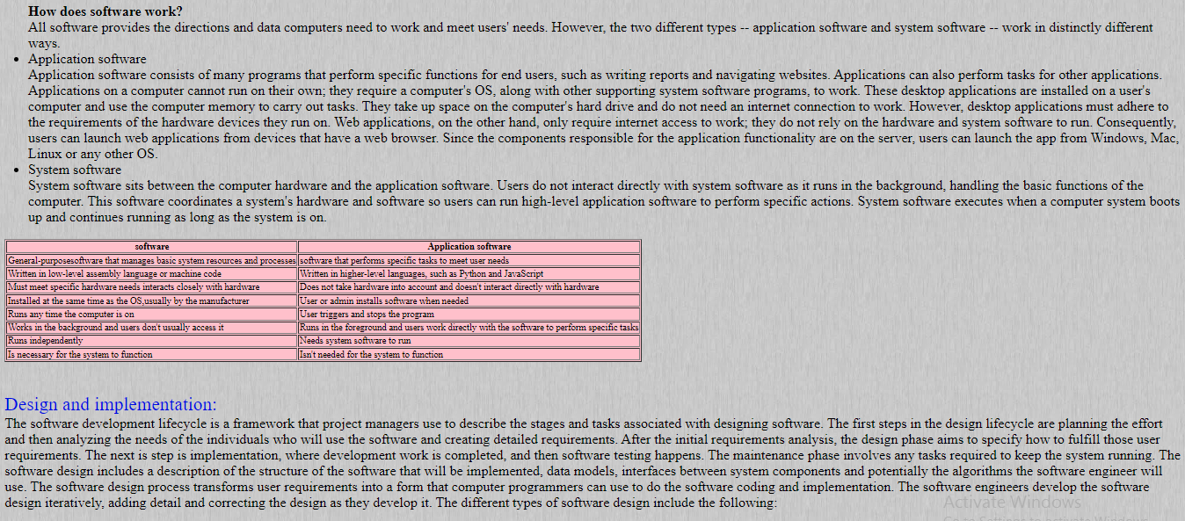

img.7 Software Architecture

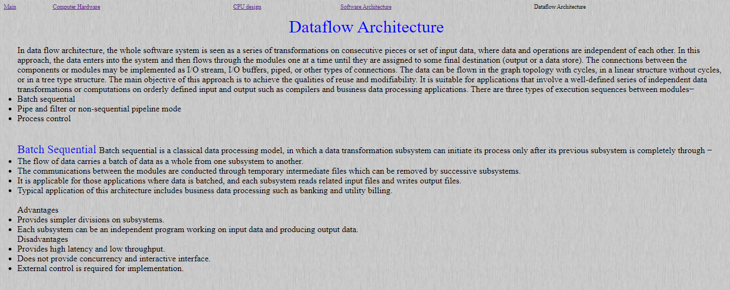

img.8 Dataflow Architecture

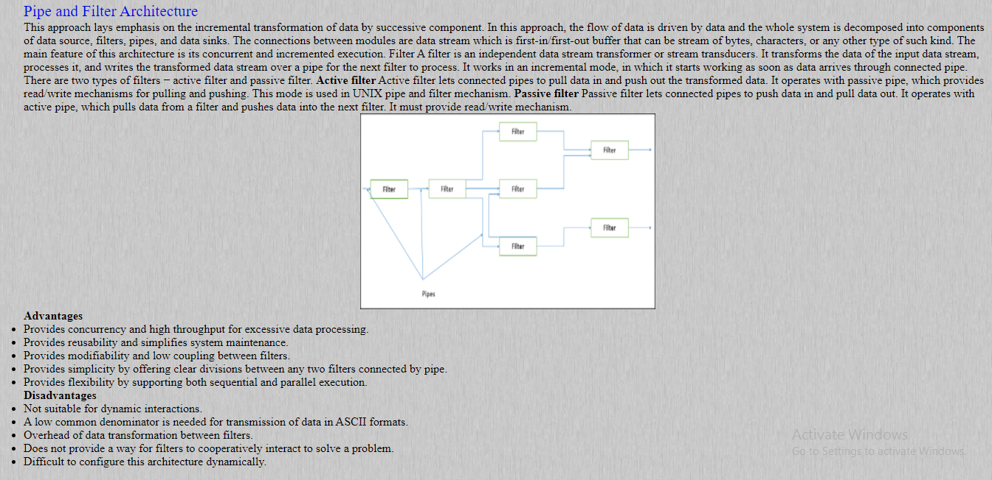

img.9 Dataflow Architecture

**Source code Screenshots:**



